**Option 2: Build Mr.HelpMate AI**

Query – 1: What is the premium rate for the member insured?

Search Layer:

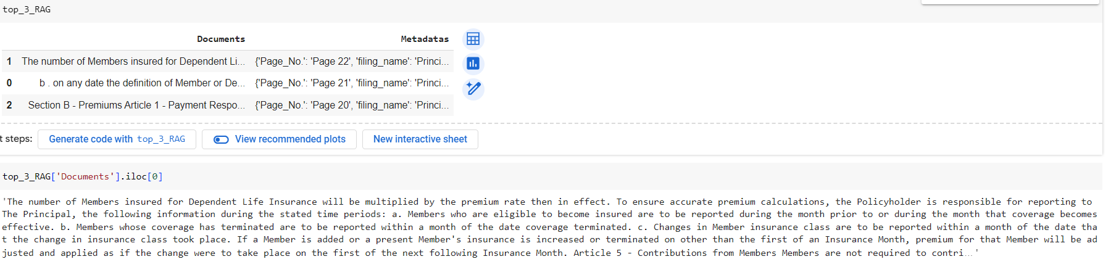

Generation Layer:

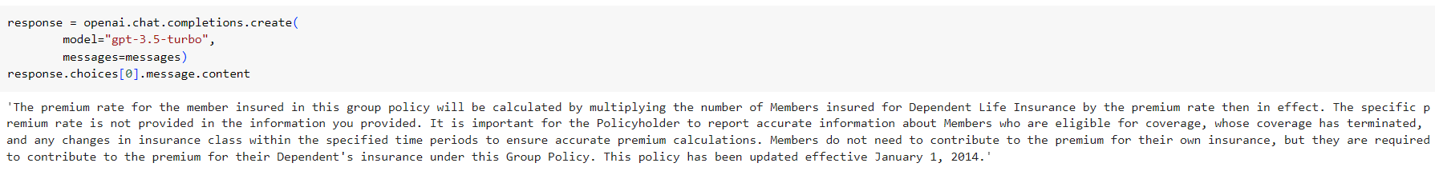

Query – 2: What is the eligibility criteria for dependents?

Search Layer:

Generation Layer:

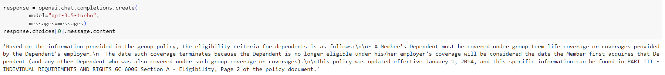

Query – 3: What is the policy for failure to pay the premium?

Search Layer:

Generation Layer:

